**CRITICAL FACTORS AFFECTING THE USE OF FINITE ELEMENT ANALYSIS FOR ROTOMOLDED PARTS**

*Hashim Bhabha, Dr.Christopher Liauw, Dr. Howard Taylor, Jason Condliffe, Manchester Metropolitan University, Manchester, UK*

*Dr. Nick Henwood, Rotomotive Ltd., Northampton, UK.*

**Abstract**

Computer aided engineering (CAE) technologies, such as finite element analysis (FEA) of stresses offers the capability to optimize and validate engineering designs within a virtual environment, enabling potential problems to be highlighted and development time to be decreased. FEA has been used widely in the rotomolding industry, although it does not always appear to give an accurate prediction of behavior in the field. This paper examines several aspects with the aim of ensuring better correlation between FEA and actual part performance. Aspects considered include: Is Young’s Modulus representative of real stiffness? How important is Poisson’s Ratio? What is the effect of wall thickness variation in moldings?

**Introduction**

Currently, FEA is widely used in the rotomolding industry to ensure products will be within the dimensional tolerance specified, withstand the loads required and last the intended lifecycle [1]. When verifying the structural integrity of parts using FEA, engineers require accurate numerical materials data. Therefore, it is crucial to ascertain which material parameters are required for FEA and to understand their effect on simulation results.

FEA is ultimately a numerical approximation [2] and is rarely an exact representation of the behavior of a product. Parameters such as geometrical dimensions, yield strength, modulus and Poisson’s ratio play a role in the accuracy of FEA simulations. With this in mind, it is appreciated that the wall thickness of rotomolded products can vary considerably, particularly for larger and more complex moldings. The latter condition presents a formidable challenge to FEA engineers, primarily due to geometrical differences between the ideal 3D computer aided design (CAD) models and the actual rotomolded product. Furthermore, the onset of non-linearity of stress-strain behavior polymers at low strains and complex behavior due to creep, introduces additional challenges for FEA engineers. For example, it is questionable whether a useful value of Young’s modulus or Poisson’s ratio can be can be determined for a polymer as non-linear behavior is observed at very low strains. This is particularly true of semi-crystalline thermoplastics which have a glass transition temperature (Tg) below ambient temperature. If such factors are not properly taken into account for when performing an FEA simulation, the actual product may behave in an unexpected manner.

Conversely, FEA simulation times increase with an increase in volume of input data (such as material properties, loads, and constraints, etc.). Therefore, it is important for engineers to simplify FEA models to reduce simulation times; a task conducted most effectively when the parameters and methods required for FEA are properly understood [3].

For initial investigations, a simple rotomolded safety step, enveloping a space of approximately 485mm length x 280mm width x 195mm height), was physically tested and compared with FEA predictions. Various FEA simulation types (static linear-elastic and non-linear, applying either a force or a displacement) were selected for comparison. Tensile test pieces were cut from the flat surfaces of the safety step and were used to determine values of Young’s modulus and tensile stress at yield for use in the FEA simulations. Furthermore, variations in the values of Poisson’s ratio for rotomolded materials (according to literature and general consensus) places a question mark over the extent at which this factor affects FEA simulations. Therefore, the Poisson’s ratio was varied during FEA simulations on the safety step in order to gauge the whether this factor significantly affects the outcome of results.

This paper examines the effect of a selection of material data from physical testing (such as modulus and Poisson’s ratio) on the outcome of linear and non-linear FEA simulations.

**Experimental**

**Safety step material**

The safety step was molded using Linear Medium Density Polyethylene (LMDPE). The commercial name for this particular grade was Revolve N-250, available in powder and pellet form from Matrix Polymers Ltd. The N-250 LMDPE grade is said to have a wide processing window and excellent moldability whilst retaining good impact strength. A selection of mechanical properties for N-250 is available within Table 1.

Table 1. Properties of N-250 LMDPE.

|  |  |  |  |
| --- | --- | --- | --- |
| **Physical Properties** | **Test Method** | **Value** | **Units** |
| Melt Flow Rate | ISO 1133 | 7.0 | g/10min |
| Density | ISO 1183 | 0.935 | g/cm³ |
| Tensile Strength @ Yield (50mm/min) | ISO 527 | 16.8 | MPa |
| Flexural Modulus (1.3 mm/min) | ISO 178 | 645 | MPa |
| ARM Impact  (-40 °C, 3 mm thickness) | ARM-I Standard | 101.6 | J |

**Compression Testing of Safety Step**

Compression testing of the safety step was conducted using a Hounsfield HK50S tensometer fitted with a 50 kN load cell, in accordance with BS EN 14183:2003 E for the testing of safety steps. Crosshead speed was 1mm/min. The ambient temperature was 23 °C (± 1°C). A total load of 600 N was applied to the top center of the safety step by a 75 mm diameter, 25mm thick compression platen through a 100 mm diameter, 6 mm thick aluminum disc. Force and crosshead displacement were recorded up to 600 N and the crosshead returned to the start position. The real time stress-strain curve generated from the raw force – deflection data revealed that the 600 N load produced strains within the linear-elastic region of the material.

Two Mitutoyo dial test indicators (DTI) were installed on the opposing sidewalls of the safety step at predefined areas of maximum deflection (determined using FEA). Sidewall deflection of the step was measured at 20 N intervals. One hour after the test, the permanent deflection of both sidewalls was 0.07mm and 0.08mm, respectively.

**Tensile Testing of Safety Step Material**

Flat surfaces were cut out from the side walls of the safety step using a band saw. Six tensile test pieces were then cut from these surfaces using an OMAX water jet cutter. The profile was generated using the CAD package built into the control system of the machine. It is appreciated that compression testing of the step may have affected the properties of the material, however, the test remained well within the linear region of the safety step material; any permanent deflection was considered negligible.

Samples were tested in tension using a Hounsfield H10KS tensometer fitted with a 10 kN load cell. The ambient temperature was 23 °C (± 1°C). Tensile testing to failure was carried out in accordance with ASTM D638. Cross head speed was 50 mm min-1. Low strains were measured using an LVDT (the Hounsfield 100s extensometer) and higher strains measured using the integrated 100 R extensometer.

Gauge length was 50 mm. The specimens were supported in the tensile position using manually tightened grips. Before testing, the sample dimensions were measured to the nearest 0.1 mm using a digital caliper. After collection of the data, the raw load - deflection data points were exported to MS Excel for further processing. Six replicate test pieces of each material were measured in order to generate average values and corresponding standard deviations.

The Young’s Modulus, tensile stress at yield and tensile strain at yield values were calculated using the Hounsfield Q-Mat software as part of the test routine selected. Modulus values generated by the Q-Mat software were checked via linear regression of the raw data and values were generally found to be only slightly different to those generated by the software.At least six replicate tensile samples of were tested; averages and standard deviations were calculated.

**FEA Software**

SolidWorks 2012 CAD software, combined with its specialist third-party FEA application was the software of choice for this research. In principle, FEA software splits a 3D geometry into a vast array of nodes (small dots), lines enjoining these nodes create an overall mesh of triangular elements. The software then calculates stress and strain across all elements and approximates a total solution for the entire geometry.

In order to use the FEA application within SolidWorks, a CAD file of the safety step was uploaded into the software. A simulation tab within the user interface was then selected, prompting a pop-up window offering analysis type options, such as static linear-elastic or non-linear. Loads, deflections and constraints were then defined by highlighting faces or edges of the 3D safety step geometry and selecting either load or constraint. The magnitude and direction of loads or constraints were also specified; a 600 N force was applied through a 0.0314 m2 area (100 mm diameter disc) on the top center surface of the step (replicating the physical test scenario, (see Figure 1). Ground contacts of the safety step (feet) were secured using stabilising springs (to contain, rather than eliminate, slight movements during loading) and the effect due to gravity was accounted for.

During the physical compression test of the step, the maximum deflection of the compression platen at 600 N was approximately 13 mm. Therefore, a displacement of 13 mm was also applied on FEA models (instead of the 600 N load) to gauge the effect of this technique on FEA results.

To simplify the FEA simulation, the 3D step geometry was halved along its vertical line of symmetry (see Figure 1), therefore, the area and magnitude of the applied force was also halved; 300 N force applied over a 50 mm radius semi-circle. The line of symmetry allowed the software to calculate stress and strain in half of the geometry (providing the geometry is symmetrical) and replicate the results for the remaining half, reducing simulation time considerably.

Figure 1. CAD geometry of safety step with loads, constraints and mesh applied. The geometry has been split along its line of symmetry to simplify the model.

Physical test data from the safety step had been used for FEA simulations. Primarily, two main analysis types were conducted within SolidWorks FEA; static linear-elastic and non-linear. Static linear-elastic simulations required values of Young’s modulus, tensile stress at yield and Poisson’s ratio. Non-linear simulations required a Poisson’s ratio value and a full tensile stress-strain curve taken from the safety step material during physical testing; eliminating the need to specify a Young’s modulus or tensile stress at yield value.

The option to vary the Poisson’s ratio was available for both static linear-elastic and non-linear simulation types, however, this was assumed to be 0.3 for initial investigations. With the essential details defined (geometry, loads, constraints and material properties), a medium mesh size was selected with no units specified, and the simulation initiated. Solutions took approximately 1 minute for static linear-elastic simulations, non-linear simulations took approximately 20 minutes.

Prior to actual compression testing of the step, a static linear-elastic FEA simulation was set up within SolidWorks. The aim was to identify the points of maximum sidewall deflection (prior to physical testing) as a consequence of the safety step geometry, therefore, accurate material properties were not necessary. FEA predicted the maximum sidewall deflection to occur approximately one quarter of the distance down the sidewall (50 mm) from the top surface of the safety step. Mitutoyo DTIs were then placed at these particular points on both sidewalls during the physical test to take sidewall deflection measurements.

Preliminary hand calculations using beam theory were conducted and compared with results from FEA simulations of beam bending to validate the calculation of the software.

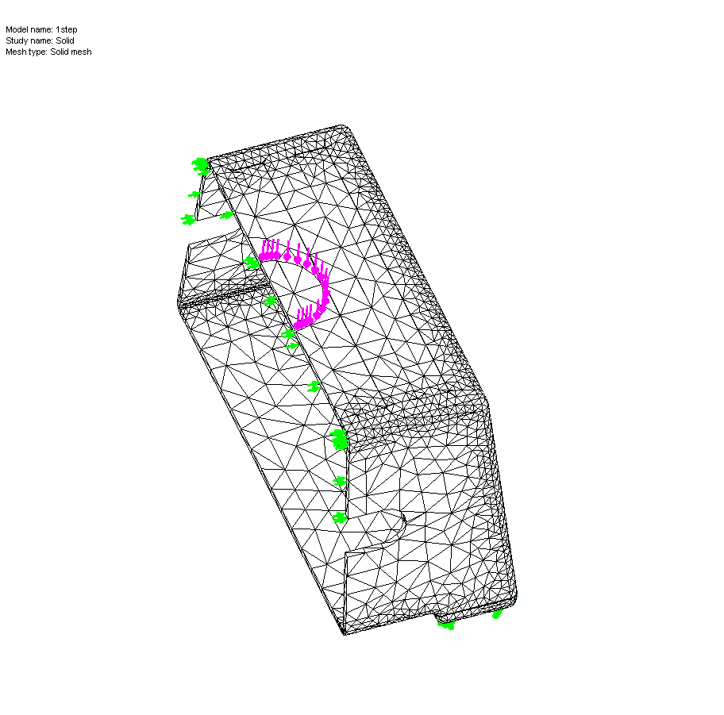

Load or Displacement

Constraints

Mesh

**Results and Discussion**

**Testing of Safety Step and Comparison with FEA**

A compression test on the safety step was conducted to obtain linear response data to compare against FEA predictions. DTIs were installed on two opposing sidewalls of the safety step at the FEA predicted areas of maximum deflection. During the test, a maximum load of 600 N was applied, corresponding to a 13 mm deflection of the compression platen (see Figure 2). This load was significantly less than the maximum required load (2600 N load, approximately 265 kg) specified in the BS standard for the testing of safety stools (BS EN 14183:2003 E), to which the safety step was compliant. The test remained within the linear region of the material. Both sidewall deflection measurements were reasonably consistent for the duration of the compression test (**see** Figure 3) confirming the step was suitable for testing. One hour after the test, the permanent deflection of both sidewalls was 0.07 mm and 0.08 mm respectively. The average sidewall deflection measurement of 1.59 mm at 600 N was compared against FEA predictions.

Within the SolidWorks FEA software, static linear-elastic and non-linear simulations were conducted (see experimental section for details); a 600 N force or a 13 mm displacement (downwards from the top surface) was applied to the safety step geometry to replicate the physical test scenario. Therefore, four FEA simulations were conducted in total. Linear-elastic simulations assumed a Young’s modulus of 500 MPa, tensile stress at yield of 15.9 MPa and a Poisson’s ratio of 0.3; tensile parameters were calculated via tensile testing of safety step material specimens. Figure 4 exemplifies the average stress-strain response of the tensile test specimens (the response of all specimens were very similar).

Non-linear simulations required an entire tensile stress-strain curve to be input as a custom material. Non-linear simulations using actual tensile stress-strain data were expected to provide better accuracy as FEA uses the stress-strain data as a reference from which to extrapolate solutions. Static linear-elastic simulations were expected to provide a quicker solution time at the expense of accuracy.

Figure 2. Force-deflection response of safety step under compression.

Figure 3. Average sidewall deflection readings from step compression test. Horizontal error bars highlight the standard deviation for each data point.

Figure 5 indicates that the opposite had occurred; the non-linear simulations underestimated the sidewall deflection of the safety step and took more time to solve, particularly the non-linear FEA force model (in the latter case error was greater than 50%). However, the static linear-elastic force and displacement simulations were more accurate with considerably shorter solution times.

Figure 4. Average tensile stress-strain response of safety step material calculated from six replicate tensile tests. Standard deviation error bars were smaller than the data points.



Figure 5. Results of FEA simulations alongside the physical test result: LF and NLF – linear and non-linear force models, respectively. LD and NLD - linear and non-linear displacement models, respectively. *Note: the long dashed line at 1.59 mm represents the physical test result*.

In this instance, it is questionable whether non-linear FEA simulations are necessary for the safety step compression test. This may be due to the relatively small load (600 N) applied, which was much below the 2600 N; specified in BS EN 14183:2003 E. The 600 N load gives strains which are well within the linear elastic region of the step material. The discrepancy between physical results and FEA predictions for the safety step compression test could be due to material properties; modifying the Young’s modulus, tensile stress at yield and Poisson’s ratio may help to improve the correlation of FEA with physical testing.

It should be appreciated that only the outer-top surface of the safety step (where the load was applied) was subjected to compressive stress, whereas the inner-top surface was subjected to tensile stress. Figure 6 demonstrates that the loading scenario is more complex than may initially be considered.

Compression of top surface

Tension in outer-fibres

Figure 6. Tensile strain in the outer-fibres of a 3 point bend test piece when compressed on the top surface.

In response to this, it was found that SolidWorks 2012 assumes that the compression stress – strain behavior of a given material is a mirror image of the tensile behavior. The latter assumption may not be true, illustrating the importance of understanding the methods and capability of FEA software. Without fully understanding the underlying principles of FEA software, realistic solutions may not be possible and the lack of understanding could result significant errors during analysis. To further clarify, the following considerations should be taken into account when using FEA:

* Determining experimental error.
* Verifying results using hand calculations.
* Understanding the implications of boundary conditions effectively (loads, constraints, material data).
* Interpretation of results.

Attention to fine details such as constraints, loading scenarios and material data should be verified before simulation results are considered. For example, it is common to find areas of maximum stress in constrained areas of geometry during FEA (e.g. the mounting point of a cantilever beam), this may not be representative of the physical world, leading to inaccurate FEA models.

Obtaining a specific Poisson’s ratio (ratio of lateral to longitudinal strain) value for the safety step material may also help to correlate FEA with physical test results. In the case of rotomolded LMDPE, there is little experimental data or literature regarding the Poisson’s ratio **[4, 5]**. However, a general consensus amongst experts in FEA of rotomolded parts suggests the Poisson’s ratio to be between 0.40 and 0.46. Several possible reasons behind the scarcity of literature regarding rotomolded LMDPE are:

* The difference between the Poisson’s ratio of rotomolded PE relative to other methods of manufacture (such as injection molded PE) is assumed to be insignificant.
* The effect of varying the Poisson’s ratio on the accuracy of FEA simulations is thought be minimal.
* Physical experiments require expensive specialist technology such as lateral extensometers, high-resolution cameras, lasers or ultra-sound equipment to measure Poisson’s ratio of PE, due to the non-linearity of PE at low strains.

**Effect of varying the Poisson’s ratio on sidewall deflection during FEA.**

For the purpose of this sensitivity study, the same static linear-elastic and non-linear FEA models (applying either a force or a displacement**)** described in the experimental section were conducted. The sidewall deflection of the step was the parameter under observation upon varying the Poisson’s ratio. The values of Poisson’s ratio used were 0.1, 0.2, 0.3, 0.4 and 0.49. The FEA software recognized a value of 0.5 for Poisson’s ratio to be incorrect (as it suggests the material is perfectly incompressible); this was the rationale behind using the value of 0.49.

Figure 7 identifies that for both static linear-elastic and non-linear displacement models, the sidewall deflection remained relatively unchanged with the change in Poisson’s ratio, except for the non-linear displacement model with a Poisson’s ratio of 0.49, whereby the sidewall deflection suddenly decreases; this is not surprising as a near incompressible material would deflect less theoretically. The non-linear force models show an extremely small (arguably negligible) decrease in sidewall deflection with the increase in Poisson’s ratio (between 1.22 and 1.17mm) except in the case of 0.49 for Poisson’s ratio, whereby the sidewall deflection increases back to 1.22mm. The static linear-elastic force models decrease in sidewall deflection with every increase in Poisson’s ratio; this appears to be accurate as the increase in Poisson’s ratio effectively decreases the extent of lateral deflection (relative to longitudinal compression).



Figure 7. Effect of Poisson’s ratio on FEA predicted sidewall deflection of safety step: Linear elastic (△) and non-linear (▲) force models. Non-linear (□) and linear-elastic (■) displacement models. *Note: the long dashed line at 1.59 mm represents the physical test result*.

Figure 7 also confirms that the static linear-elastic simulations are more accurate in this instance than equivalent non-linear simulations. Furthermore, the static linear-elastic displacement models appear to be relatively unaffected by the change in Poisson’s ratio. The same is true for the sidewall deflection of all non-linear displacement models, whereby the sidewall deflection did not deviate significantly with the increase in Poisson’s ratio. However, odd results are apparent for all non-linear models where an unrealistic value of 0.49 for the Poisson’s ratio was used. To conclude, Figure 7 suggests that the change in Poisson’s ratio for PE has a relatively small impact on the results of FEA simulations.

**Conclusions**

Initial FEA investigations replicated a physical compression test conducted on a small rotomolded safety step. Tensile and compression specimens cut from the safety step were also tested to obtain mechanical response data for comparisons with FEA. Moreover, a study to gauge the effect of varying the Poisson’s ratio on the sidewall deflection of the FEA safety step model was also conducted. The following conclusions were derived from investigations:

* Measured values of sidewall deflection for the safety step coincided well with FEA predictions for non-linear displacement models and static linear-elastic force and displacement models. Non-linear force model simulations were almost 50% less than expected to be; the mechanical behavior of PE can be non-linear even at very low strains, therefore, PE properties could change simultaneously with applied load, possibly explaining the deviation between FEA predictions and physical measurements. However, this deviation could be minimized by optimizing the Young’s modulus or tensile stress at yield parameter.
* Non-linear FEA models (using tensile data from physical tests) took considerably longer to solve than equivalent static linear-elastic models with no advantage in terms of accuracy. In fact, the non-linear force model FEA predictions significantly deviated from physical measurements. Linear-elastic force and displacement FEA simulations were surprisingly more accurate with considerably shorter solution times.
* SolidWorks FEA software assumes the compressive stress-strain response of the safety step material to be a mirror image of the tensile equivalent, which is not true. The use of a combined tensile-compression stress-strain curve for FEA of the safety step (to account for the compression on the top surface and tension in the outer surface skin during loading) should be considered.
* The non-linearity of PE at low strains makes testing for the Poisson’s ratio a formidable challenge, explaining the scarce availability of literature regarding the Poisson’s ratio of PE.
* Small variations in Poisson’s ratio for PE have a relatively minimal impact on the results of FEA simulations. However, in the case of the safety step the load applied and the wall thickness was low. Larger rotomolded products with higher stresses and larger wall thicknesses may behave differently.

References

1. T. D, Nguyen. *Finite Element Analysis of a Nose Gear During Landing,* University of North Florida, School of Engineering Theses and Dissertation Paper 215, pp. 4 (2010).

# R.H. Shih. *Introduction to Finite Element Analysis Using Creo Simulate 1.0,* SDC Publications, pp. 2 (2011).

1. M.S. Gockenbach, *Understanding and Implementing the finite element method*, Society for industrial and applied mathematics (SIAM), pp. xiii (2006).
2. C.Milton, *Predicting Strength of Rotomoulded Parts,* Tennant Company, Minneapolis, pp. 4 (2011).
3. L.W. Mckeen. *The effect of creep and other time related factors on plastics and elastomers,* Plastics Design Library, New York, pp. 27 (1991)